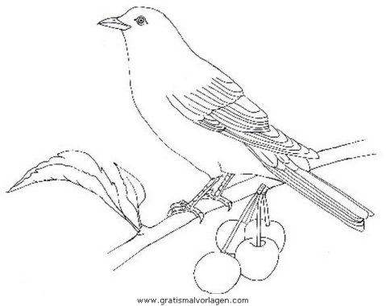
Fortpflanzung am Beispiel der Amsel

1. Vogelsang:

____________________________________________________________________________________________________________________________________________________________________________________

2. Männchen besetzen Reviere:

____________________________________________________________________________________________________________________________________________________________________________________

3. Paarbildung:

____________________________________________________________________________________________________________________________________________________________________________________

4. Paarung:

____________________________________________________________________________________________________________________________________________________________________________________

5. Nestbau und Eiablage:

____________________________________________________________________________________________________________________________________________________________________________________

6. Brutpflege:

____________________________________________________________________________________________________________________________________________________________________________________

Nesthocker | Nestflüchter
_____________________________  _____________________________  _____________________________  Beispiele: _________________  _________________  _________________ | _____________________________  _____________________________  _____________________________  Beispiele: _________________  _________________ _________________

